Dear Workshop participant,
We are excited to have you join us for the Theory to Code: GLM, GBM, Deep Learning in Python Workshop at the upcoming 2026 CAS Ratemaking, Product and Modeling Seminar. The workshop will take place on Monday, March 16th from 1:00 PM – 5:00 PM. Topics covered include:
- Generalized Linear Models
- Gradient Boosting Machines
- Neural Network and Reinforcement Learning models
You will have access to the notebooks for use during and after the workshop. The notebook repository is located here:
https://github.com/RuthlessActuary2023/CAS-RPM-2026-Theory-to-Code
Please go to the link above and confirm you can open the “req_test” notebook and run the first 3 cells using google colab. This requires a google account – if you do not have one, please make one now.
We are very excited to see you and help you accelerate your Python journey.

Sincerely,
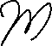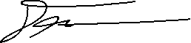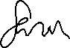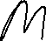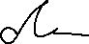
Marcus Deckert & Sarah McCracken

